**Figures**

Figure 1: SP for 2008 and 1998

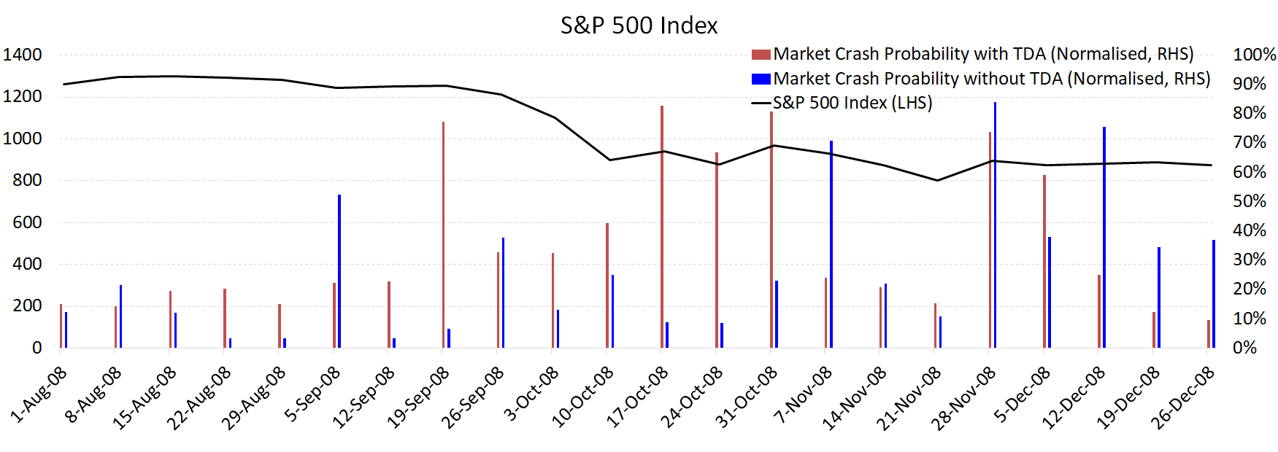

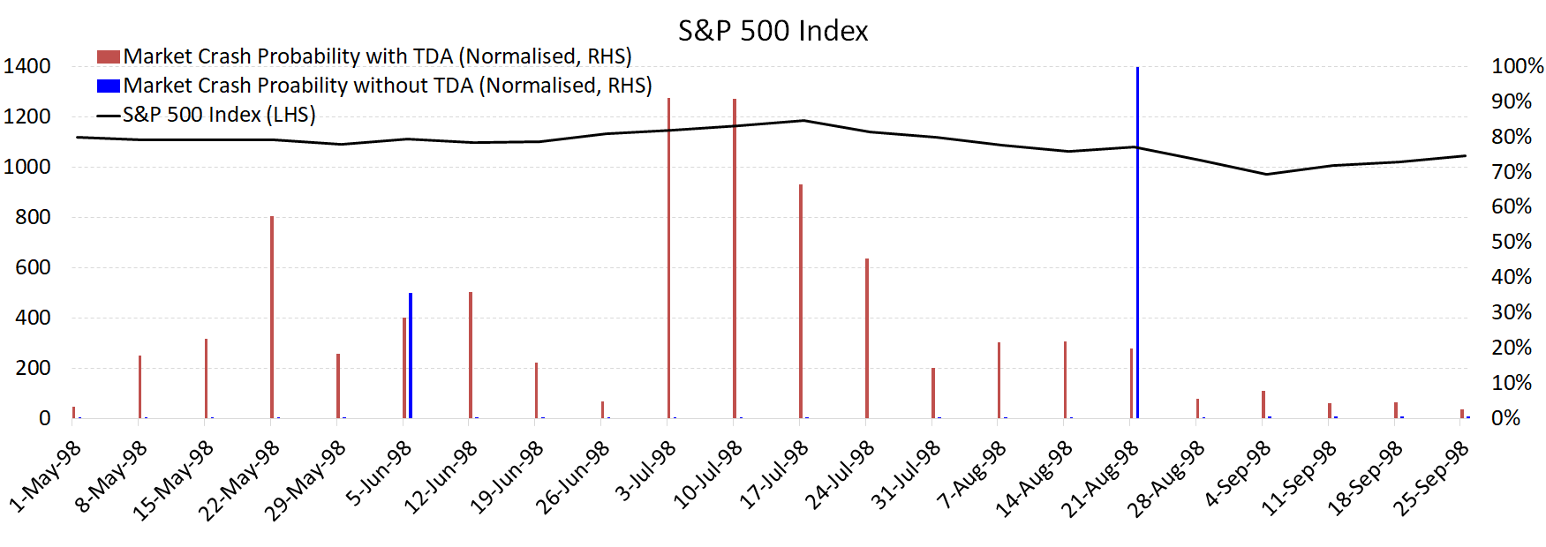

**Figure 1:** This figure shows the market crash probabilities for the S&P 500 index using the Early Warning System discussed in Section 2, incorporating TDA features (red bars) and without TDA features (blue bars). The crash probabilities are shown around the period of the 2008 market decline (top panel) and the 1998 market decline (bottom panel). Details of TDA and how it is used in this context are given in Section 2.

Figure 2: FTSE and HSI for 2008

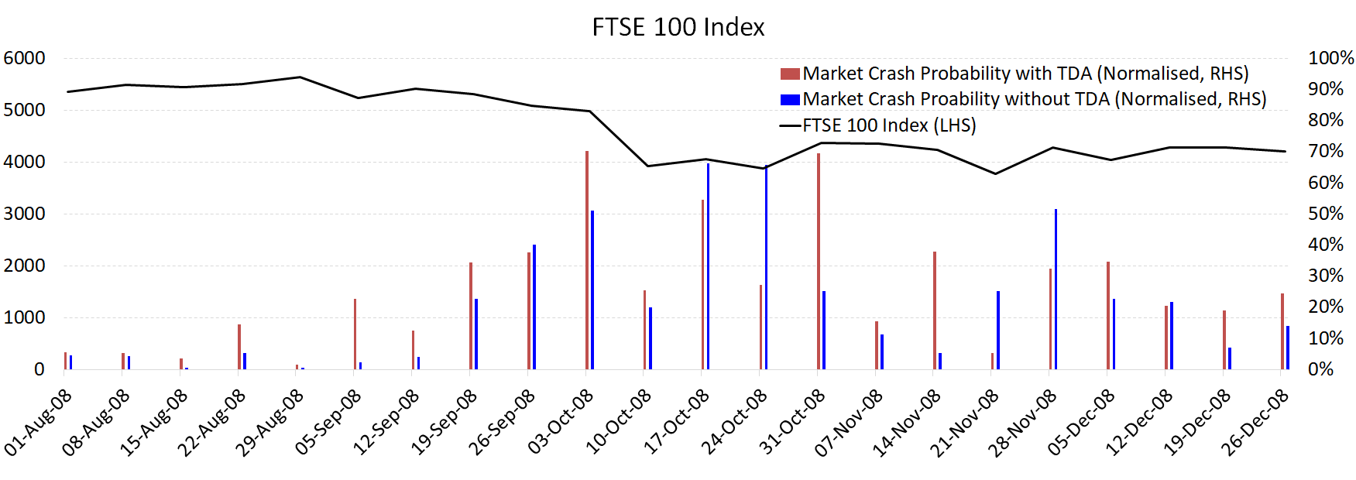

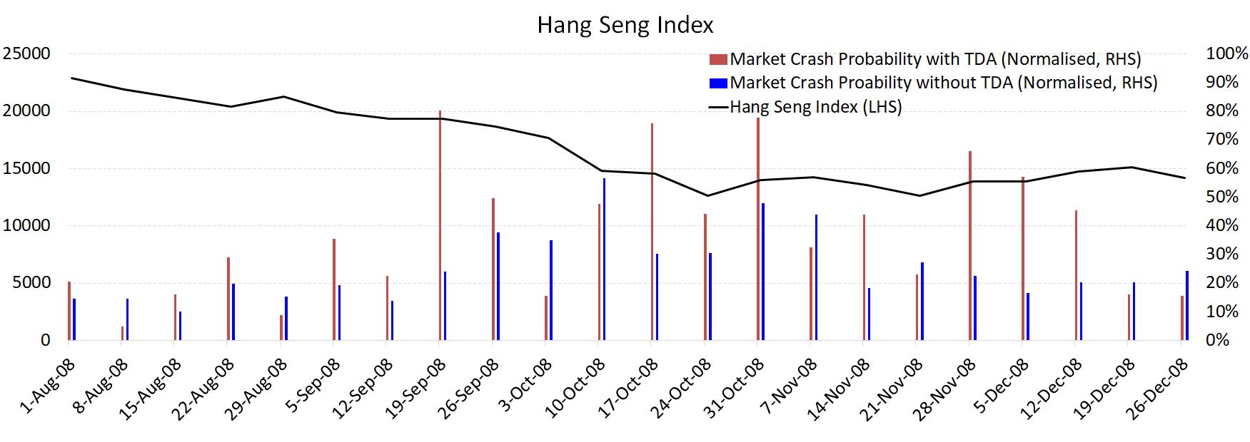

**Figure 2:** This figure shows the market crash probabilities for the FTSE 100 (upper panel) and the Hang Seng Index (lower panel) using the Early Warning System discussed in Section 2, incorporating TDA features (red bars) and without TDA features (blue bars). The crash probabilities are shown around the period of the 2008 market. Details of TDA and how it is used in this context are given in Section 2.

Figure 3: Feature weights for SP 2008 and 1998 with and without TDA

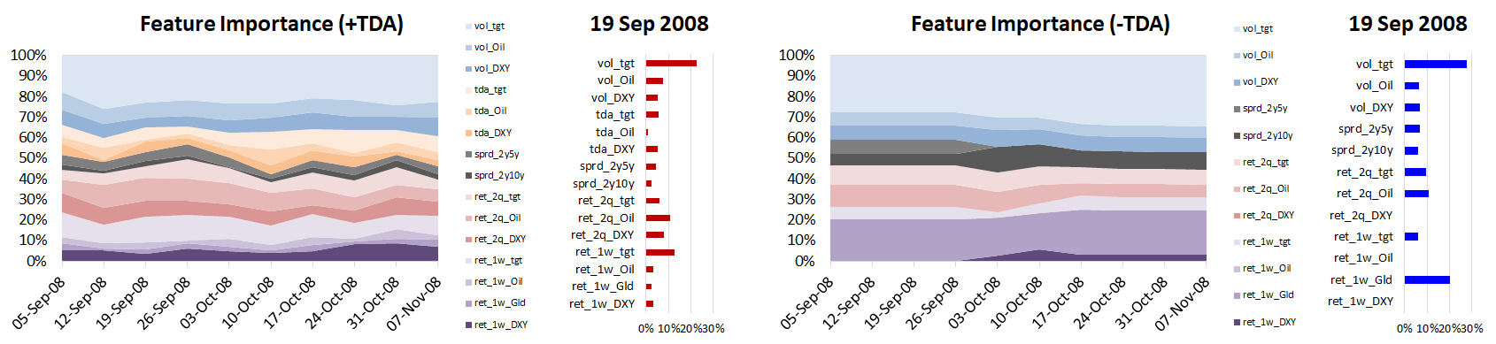

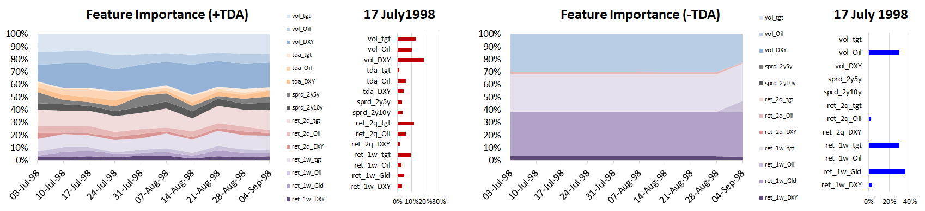

**Figure 3:** This figure shows the weightings of the various features for the S&P 500 used in our Early Warning System over the period of the 2008 market decline (upper panel) and the 1998 market decline (lower panel). For the top two sub-panels the graph on the left side shows the weightings over the September to November 2008 period while the one on the right is the weightings on a specific date, 19th of September. For the bottom two sub-panels the left side shows the weightings over the July to September 1998 period, while the one on the right shows the weightings on the 17th of July 1998. For both the top and bottom panel the sub-panel on the right incorporates the TDA features while the one on the left omits TDA features. Details of the Early Warning System, feature selection and weighting with and without TDA are provided in Section 2.

Figure 4: Feature weights for FTSE and HSI 2008 with and without TDA

FTSE 100

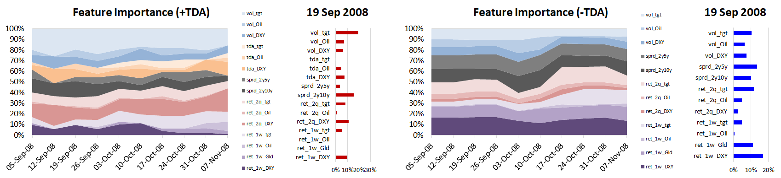

Hang Seng

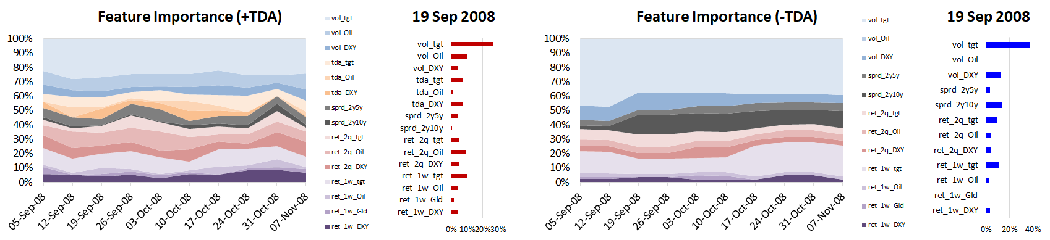

**Figure 4:** This figure shows the weightings of the various features for the FTSE 100 (upper panel) and Hang Seng Index (lower panel) used in our Early Warning System over the period of the 2008 market decline. For the four sub-panels the graph on the left side shows the weightings over the September to November 2008 period while the one on the right is the weightings on a specific date, 19th of September. For both the top and bottom panel the sub-panel on the right incorporates the TDA features while the one on the left omits TDA features. Details of the Early Warning System, feature selection and weighting with and without TDA are provided in Section 2.

Figure 5: F1 Score for SP, FTSE, HSI

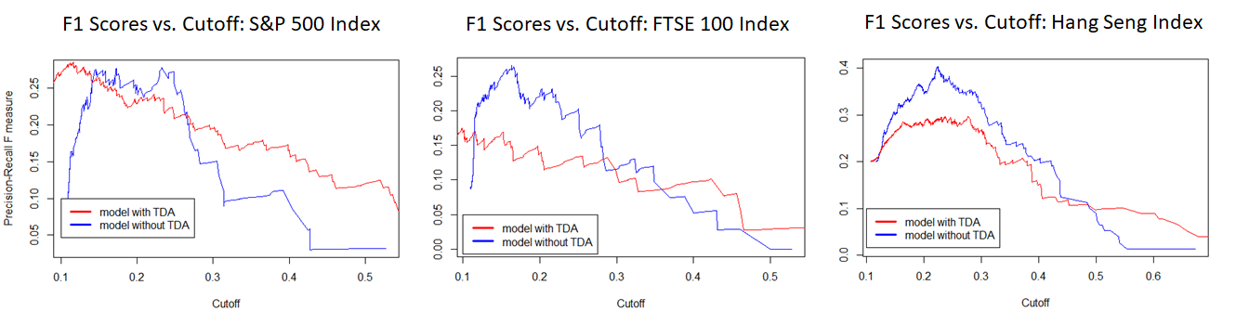

**Figure 5:** This figure shows the F1 score for our Early Warning System with TDA features (red line) and without TDA features (blue line), as a function of the cut-off probability. These are shown from left to right for the S&P500, the FTSE100 and the Hang Seng Index and the time period is 1993-2018. The F1 score is a measure of false negatives and is discussed in more detail in Sections 2 and 3. Details of the Early Warning System as well as TDA are given in Section 2.

Figure 6: Crash Probability with and without TDA, AUC for SP

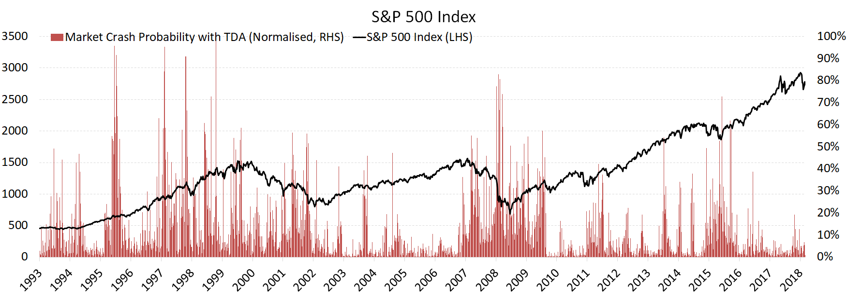

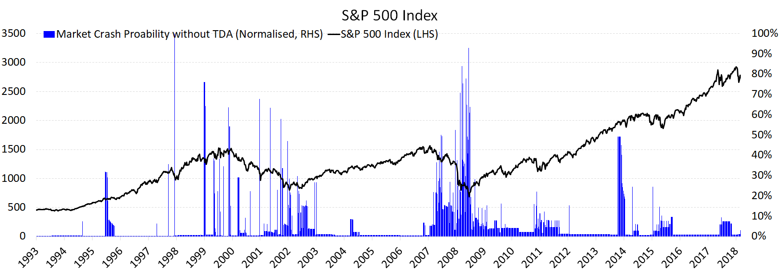

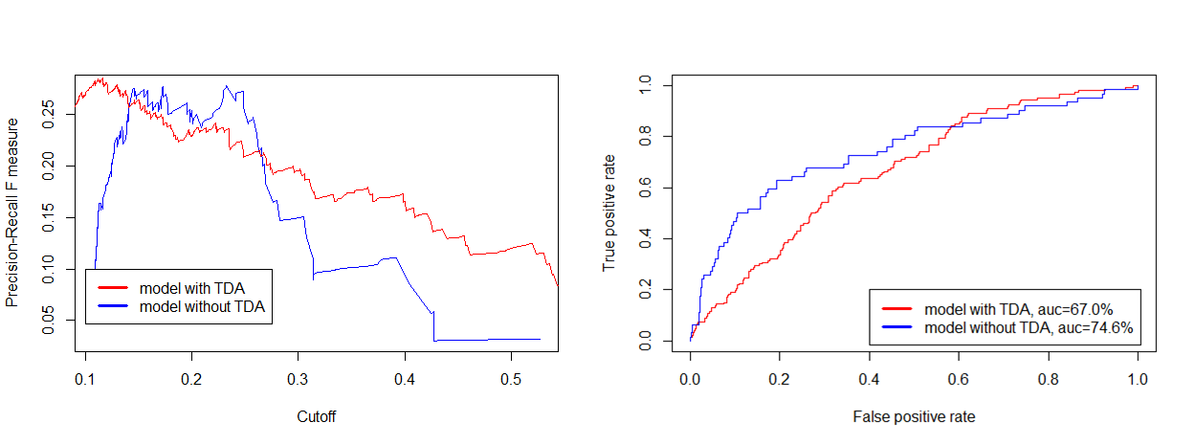

**Figure 6:** The upper panel of this figures shows the evolution of crash probabilities for the S&P 500 over the 1993-2018 period (red bars) together with the level of the S&P500 (black line), when TDA features are incorporated. The middle panel shows the evolution of the crash probabilities (blue bars) when TDA features are omitted together with the level of the S&P500 (black line) over the 1993-2018 period. The bottom panel shows the Precision Recall measure for the S&P500 over the 1993-2018 period as a function of the cutoff probabilities. The Precision Recall measure is a measure of false positives and is discussed in Sections 2 and 3. Details of the crash probabilities as well as TDA are given in Section 2.



**Table 1:** This table shows the evolution of feature weightings as the yearly averages of the feature weightings over the 1994-2018 period for the Early Warning System for the S&P 500. The left most column (Agg TDA weights) is the sum of the weightings of the three TDA features described in Section 2. The three other features considered are the lagged 1 week return on the S&P500 (Ret 1w), the lagged one week return on gold (Ret 1w Gold) and the lagged volatility of the S&P 500 (Vol tgt). The columns with TDA show these feature weightings when TDA features are also incorporated while the other ones are the weightings without TDA features incorporated. Details of the Early Warning System, TDA features, and feature weightings are in Section 2.